 | 7.3.11 Editors - 3D Viewport - Sidebar - Tool Tab - Grease Pencil Object - Sculpt Mode
Table of content
Sculpt Mode 2
Sculpt Mode - Brushes Panel 2
Brush browser 2
Sculpt Mode - Brush Settings Panel - Smooth Brush 3
Radius 3
Strength 3
Sculpt Strokes sub panel 3
Affect Position 3
Affect Strength 3
Affect Thickness 3
Affect Pressure 3
Affect UV 3
Sculpt Mode - Brush Settings Panel - Thickness Brush 3
Radius 3
Strength 3
Add / Subtract 3
Sculpt Mode - Brush Settings Panel - Strength Brush 4
Radius 4
Strength 4
Add / Subtract 4
Sculpt Mode - Brush Settings Panel - Randomize Brush 4
Radius 4
Strength 4
Sculpt Strokes sub panel 4
Affect Position 4
Affect Strength 4
Affect Thickness 4
Affect UV 4
Sculpt Mode - Brush Settings Panel - Grab Brush 5
Radius 5
Strength 5
Sculpt Mode - Brush Settings Panel - Push Brush 5
Radius 5
Strength 5
Sculpt Mode - Brush Settings Panel - Twist Brush 5
Radius 5
Strength 5
Clockwise/Counter Clockwise 5
Pinch / Inflate 5
Sculpt Mode - Brush Settings Panel - Pinch Brush 6
Radius 6
Strength 6
Pinch / Inflate 6
Sculpt Mode - Brush Settings Panel - Clone Brush 6
Radius 6
Strength 6
Sculpt Mode - Brush Settings Panel - Cursor Sub panel 6
Show Brush 6
Cursor Color 6
Inverse Color 6
Grease Pencil - Weight Paint Mode 7
Weight Paint Mode - Brushes Panel 7
Brush browser 7
Weight Paint Mode - Brush Settings Panel 7
Radius 7
Strength 7
Weight 7
Use Falloff 7
Weight Paint Mode - Brush Settings Panel - Cursor Sub panel 7
Show Brush 7
Color 7
Sculpt Mode - Options panel 8
Auto Normalize 8

Sculpt Mode

In Sculpt mode you can sculpt the grease pencil strokes.

Sculpt Mode - Brushes Panel

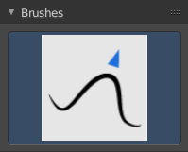
Brush browser
Pick a pencil, and see what pencil is active.
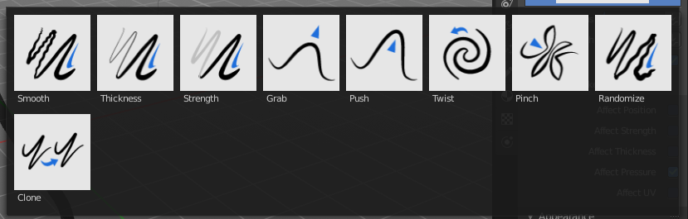

´

Sculpt Mode - Brush Settings Panel - Smooth Brush
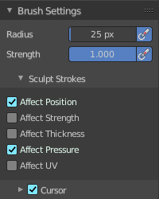

Radius
The radius of the brush.

Strength
The strength of the brush.

Sculpt Strokes sub panel

Affect Position
The brush affects the position of the point.

Affect Strength
The brush affects the color strength of the point.

Affect Thickness
The brush affects the thickness of the point.

Affect Pressure
The brush affects the pressure values as well when smoothing strokes.

Affect UV
The brush affects the UV rotation of the point.

Sculpt Mode - Brush Settings Panel - Thickness Brush
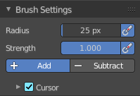

Radius
The radius of the brush.

Strength
The strength of the brush.

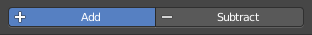
Add / Subtract
Thickness and Strength brush. If this brush should add or subtract to the sculpt surface.

Sculpt Mode - Brush Settings Panel - Strength Brush

Radius
The radius of the brush.

Strength
The strength of the brush.

Add / Subtract
Thickness and Strength brush. If this brush should add or subtract to the sculpt surface.

Sculpt Mode - Brush Settings Panel - Randomize Brush
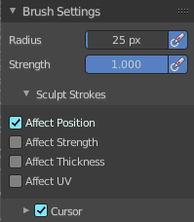

Radius
The radius of the brush.

Strength
The strength of the brush.

Sculpt Strokes sub panel

Affect Position
The brush affects the position of the point.

Affect Strength
The brush affects the color strength of the point.

Affect Thickness
The brush affects the thickness of the point.

Affect UV
The brush affects the UV rotation of the point.

Sculpt Mode - Brush Settings Panel - Grab Brush
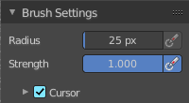

Radius
The radius of the brush.

Strength
The strength of the brush.

Sculpt Mode - Brush Settings Panel - Push Brush

Radius
The radius of the brush.

Strength
The strength of the brush.

Sculpt Mode - Brush Settings Panel - Twist Brush
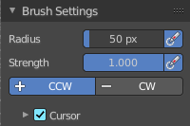

Radius
The radius of the brush.

Strength
The strength of the brush.

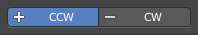
Clockwise/Counter Clockwise
If the twist goes clockwise or counter clockwise.


Pinch / Inflate
Pinch brush. If the brush should pinch or inflate.

Sculpt Mode - Brush Settings Panel - Pinch Brush
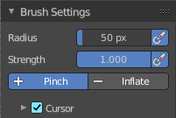

Radius
The radius of the brush.

Strength
The strength of the brush.

Pinch / Inflate
Pinch brush. If the brush should pinch or inflate.

Sculpt Mode - Brush Settings Panel - Clone Brush
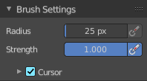

Radius
The radius of the brush.

Strength
The strength of the brush.

Sculpt Mode - Brush Settings Panel - Cursor Sub panel
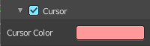
This subpanel shows with all brushes in the Brush settings panel.

Show Brush
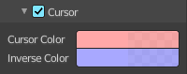
Show the brush icon when painting.

Cursor Color
The brush icon color with adding.

Inverse Color
The brush icon color with subtracting.
Inverse color does not show with all brushes. Just with Pinch for example.

Grease Pencil - Weight Paint Mode

In Weight Paint Mode you can weight paint your strokes.

Weight Paint Mode - Brushes Panel

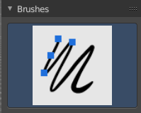
Brush browser
Pick a pencil, and see what pencil is active. There is just one pencil available for weight painting.
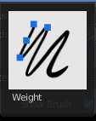

Weight Paint Mode - Brush Settings Panel

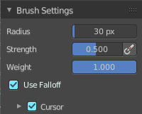
Radius
The radius of the brush.

Strength
The strength of the brush.

Weight
The target weight. Everything below gets added towards this value. Everything above gets subtracted from this value. Usually you work with the maximum value of 1.

Use Falloff
Use Falloff for the brush.

Weight Paint Mode - Brush Settings Panel - Cursor Sub panel

Show Brush
Show the brush icon when painting.

Color
The brush icon color.

Sculpt Mode - Options panel
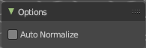

Auto Normalize
Ensure that all bone deforming vertex groups adds up to 1.0 while weight painting.

